MODULE 1
Lecture # 1

1) Synopsis: Introduction to transistors

2) Target: To study and understand (a) types of transistors (b) transistor configurations (c) Biasing of transistors etc. You should also be able to explain the working of (a) transistors.

3) Introduction
In particular, we will emphasize the following
(a)Transistors
(b)Common configurations of transistors
(c)Biasing of transistors
4) Revision / Prerequisites
Concepts of current, resistance and Ohm’s law

5.1) Concept #1

Transistors amplify current, for example they can be used to amplify the small output current from a logic IC so that it can operate a lamp, relay or other high current device. In many circuits a resistor is used to convert the changing current to a changing voltage, so the transistor is being used to amplify voltage.
A transistor may be used as a switch (either fully on with maximum current, or fully off with no current) and as an amplifier (always partly on)
There are two types of standard transistors, NPN and PNP, with different circuit symbols. The letters refer to the layers of semiconductor material used to make the transistor. Most transistors used today are NPN because this is the easiest type to make from silicon. The amount of current amplification is called the current gain, symbol h_{FE}.
.
.
5.2) Concept #2

Basically Bipolar Junction transistor consists of two back-to-back P-N junctions manufactured in a single piece of a semiconductor crystal. These two junctions give rise to three regions called emitter, base and collector. A junction transistor is simply a sandwich of one type of semiconductor material b/w two layers of other type.

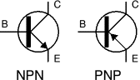
Transistor circuit symbols

Emitter:
It forms the left hand section of region of the transistor. It is more heavily doped than any of the other regions, because its main function is to supply majority carriers to the base.
Base:
It forms the middle section of the transistor. It is very lightly doped.
Collector:
It forms the right hand side section of the transistor and its main function is to collect majority carriers through the base.

5.2) Concept #3
Transistor Circuit Configurations:
Basically, there are three types of circuit connections (called configurations) for operating a transistor.
1. Common-base (CB) 2.Common-emitter (CE)
3. Common –collector (CC)
The term ‘common’ is used to denote the electrode that is common to the input and output circuits. Because the common electrode is generally grounded, these modes of operation are frequently referred to as grounded base, grounded emitter and grounded collector configurations.
In any transistor circuit design you must supply a DC bias current and voltage to
operate in the linear region of the characteristic curve. The DC operating point is defined by the values of I_{B} I_{C} V_{BE} and V_{CE} . You must also obtain the proper AC operation.
The transistor is a three-terminal device that we will use to form a four-terminal
circuit. Small voltage changes in the base-emitter junction will produce large current changes in the collector and emitter, whereas small changes in the collector-emitter voltage have little effect on the base. The result is that the base is always part of the input to a four-terminal network. There are three common configurations: common emitter (CE), common collector
(CC) and common base (CB)

CB configuration
In this configuration, emitter current I_{E} is the input current and collector current I_{C} is the output current. The input signal is applied between emitter and base whereas output signal is taken out from the collector and base. The ratio of collector current to emitter current is called dc alpha (α) of a transistor
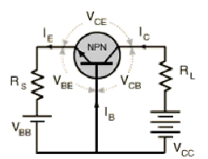
CE configuration

Here input signal is applied between base and emitter whereas output signal is taken out from the collector and emitter The ratio of collector current to base current is called dc beta(β)of a transistor.
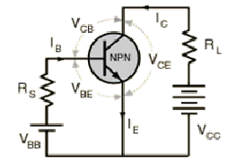

CC configuration

In this case input signal is applied between base and collector and output signal is taken out from emitter and collector circuit. The current gain of the circuit is

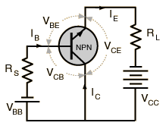

6.0) Summary
If the transistor is not biased correctly, it would
i) work inefficiently and ii) produce distortion in the output signal

7.0) Exercise questions
1. Define biasing conditions in active, saturation and cutoff regions of a BJT.
2. Define f_{t} of a BJT. What is its significance?

Lecture # 2

1) Synopsis: Biasing of transistors
2) Target: To study and understand (a) Biasing of transistors. You should also be able to explain the working of (a) transistors.

3) Introduction
Transistor biasing:
For proper working of transistor, it is essential to apply voltages of correct polarity across its two junctions. For normal operation
1) Emitter-base junction is always forward-biased and
2) Collector-base junction is always reverse biased.

In PNP transistor positive terminal of V_{EE} connected to P-type emitter in order to repel or push holes into the base. The negative terminal of V_{cc} is connected to the collector so that it may attract or pull holes through the base. Similar considerations apply to the NPN transistor. It must be remembered that a transistor will never conduct any current if its emitter-base junction is not forward biased.
4) Revision / Prerequisites
Basic principles of operation of a transistor
5.1) Concept #1
Three bias networks for the common emitter amplifier are:
a) Fixed bias b) Self bias c) Voltage divider bias
One of the basic problems with transistor amplifiers is establishing and maintaining
the proper values of quiescent current and voltage in the circuit. This is accomplished by
selecting the proper circuit-biasing conditions and ensuring these conditions are maintained despite variations in ambient (surrounding) temperature, which cause changes in amplification and even distortion (an unwanted change in a signal). Thus a need arises for a method to properly bias the transistor amplifier and at the same time stabilize its dc operating point (the no signal values of collector voltage and collector current). As mentioned earlier, various biasing methods can be used to accomplish both of these functions. Although there are numerous biasing methods, only three basic types will be considered.
5.2) Concept #2
Fixed Bias
Base-Current Bias (Fixed Bias) The first biasing method, called BASE CURRENT
BIAS or sometimes FIXED BIAS, was used in figure. As you recall, it consisted basically of a resistor (RB) connected between the collector supply voltage and the base. Unfortunately, this simple arrangement is quite thermally unstable. If the temperature of the transistor rises for any reason (due to a rise in ambient temperature or due to current flow through it), collector current will increase. This increase in current also causes the dc operating point, sometimes called the quiescent or static point, to move away from its desired position (level). This reaction to temperature is undesirable because it affects amplifier gain (the number of times of amplification) and could result in distortion.
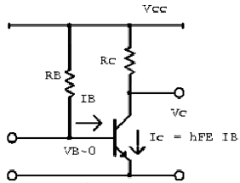

5.3) Concept #3
Self Bias
A better method of biasing is obtained by inserting the bias resistor directly between
the base and collector. By tying the collector to the base in this manner, feedback voltage can be fed from the collector to the base to develop forward bias. This arrangement is called SELF-BIAS. Now, if an increase of temperature causes an increase in collector current, the collector voltage (VC) will fall because of the increase of voltage produced across the load resistor (RL). This drop in VC will be fed back to the base and will result in a decrease in the base current. The decrease in base current will oppose the original increase in collector current and tend to stabilize it. The exact opposite effect is produced when the collector current decreases.
Self-bias has two small drawbacks:
(1) It is only partially effective and, therefore, is only used where moderate changes in
ambient temperature are expected;
(2) It reduces amplification since the signal on the collector also affects the base
voltage.
This is because the collector and base signals for this particular amplifier configuration
are 180 degrees out of phase (opposite in polarity) and the part of the collector signal that is fed back to the base cancels some of the input signal. This process of returning a part of the output back to its input is known as DEGENERATION or NEGATIVE FEEDBACK.
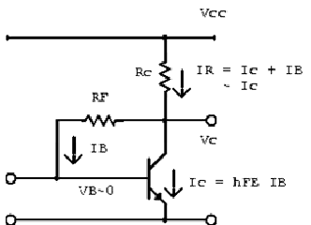

Voltage Divider Bias
A combination of fixed and self-bias can be used to improve stability and at the same
time overcome some of the disadvantages of the other two biasing methods. One of the most widely used combination-bias systems is the voltage-divider type
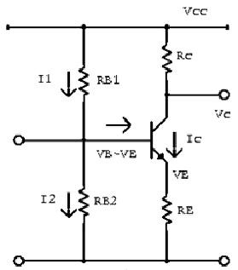

6.0) Summary
If the transistor is not biased correctly, it would
i) Work inefficiently and ii) produce distortion in the output signal

7.0) Exercise questions
1. Define biasing conditions in active, saturation and cutoff regions of a BJT.
2. What are the different biasing techniques used for BJT? Compare them on the basis of stability.

Lecture # 3

1) Synopsis: Stability and Thermal Runaway

2) Target: At the completion of this lecture you should be able to answer questions like (a) Definition of stability factor (b) thermal runaway
3) Introduction
In particular, we will emphasize the following
(a)Stability
(b)Thermal runaway

4.1) Concept #1
Stability
The degree of success achieved in stabilizing I_{C} in the face of variations in Ico is expressed in terms of current stability factor S. It is defined as rate of change of Ic with respect to I_{co} when both β and I_{B} are held constant
S=d I_{C}/ d I_{CO}
Larger the value of S greater the thermal instability and vice versa. The stability factor may be alternatively expressed by using the well known equation
I_{C}=βI_{B}+ (1+β) I_{CO}

4.2) Concept #2
Thermal Runaway:
For a CE circuit
I_{C}=βI_{B}+ (1+β)I_{CO}
The leakage current is extremely temperature-dependent. It almost doubles for every 6⁰C rise in temperature in Ge and for every 10⁰C rise in Si. Any increase in I_{co} is magnified (1+β) times. Even a slight increase in I_{co} will affect I_{C} considerably. As I_{C} increases, collector power dissipation increases which raises the operating temperature that leads to further increase in I_{C}. If this succession of increase is allowed to continue, soon I_{C} will increase beyond safe operating value thereby damaging the transistor itself – a condition known as thermal runaway.
4.3) Concept #3
When a transistor conducts current between collector and emitter, it also drops voltage
between those two points. At any given time, the power dissipated by a transistor is equal to
the product (multiplication) of collector current and collector-emitter voltage. Just like
resistors, transistors are rated in terms of how many watts they can safely dissipate without
sustaining damage. High temperature is the mortal enemy of all semiconductor devices, and
bipolar transistors tend to be more susceptible to thermal damage than most.
5.0) Summary
Stability factor S is defined as rate of change of Ic with respect to I_{co} when both β and I_{B} are held constant. Larger the value of S greater the thermal instability and vice versa.
6.0) Exercise questions
1. Define stability factor.
2. What is thermal runaway?
Lecture # 4

1) Synopsis: RC Coupled Amplifier
Frequency response
Gain Bandwidth relation
2) Target: At the completion of this lecture you should be able to answer questions like (a)types of transistors(b)Frequency response (c) Gain Bandwidth relation etc. You should also be able to explain the working of (a) RC Coupled Amplifier.

3) Introduction
. Often, the voltage amplification or power gain or frequency response obtained with a single stage of amplification is insufficient to meet the requirements of either a composite electronic circuit or a load device. Hence two or more single stages of amplification are frequently used to achieve greater voltage or current amplification or both
In particular, we will emphasize the following
(a)Working of a RC coupled amplifier
(b)Frequency response
(c)Gain bandwidth relation

4.1) Concept #1

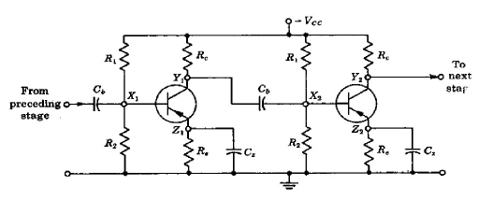
The output Y1 of the first stage is coupled to the input X2 of the next stage via a
blocking capacitor CB that is used to keep the dc component of the output voltage at Y1 from reaching the input X2. Resistor R2 is from gate to ground, and the collector circuit resistor is Rc. The source resistor Rs, the emitter resistance Re, and the resistors R1 and R2 are used to establish the bias. The bypass capacitors, used to prevent the loss of amplification due to negative feedback are Czin the emitter circuit and Cs in the source circuit. Also present are the junction capacitances, which come into play when the frequency is very high.

The connecting link between two stages is capacitor. The function of RC coupling network is two-fold:
- to pass ac signal from one stage to the next,
- to block the passage of dc voltages from one stage to the next.

The figure shows a two- stage RC-coupled amplifier which consists of two single-stage transistor amplifiers using the CE configurations.

4.2) Concept #2
Gain-Bandwidth relation.
The product of gain and bandwidth is always constant

4.3) Concept #3
Frequency Response
Amplifier gain falls off at very low as well as at very high frequencies. At low frequencies, the fall in gain( called roll off) is due to capacitive reactance of the coupling capacitor between the two stages. The high-frequency roll-off is due to output capacitance of the first stage, input capacitance of second stage and the stray capacitance.

The only drawback of this coupling is that due to large drop across collector load resistors, the collectors work at relatively small voltages unless higher supply voltage is used to overcome this large drop.
At low frequencies (<50Hz), the reactance of coupling capacitor Cc is quite high and hence very small part of signal will pass from one stage ot the next stage. Moreover, Ce cannot shunt the emitter resistance Re effectively because of its large reactance at low frequencies. These two factors cause a falling of voltage gain at low frequencies.
At high frequencies (>20KHz), the reactance of Cc is very small and it behaves as a short circuit. This increases the loading effect of next stage serves to reduce the voltage gain. Moreover, at high frequency, capacitive reactance of base-emitter junction is low which increases the base current. This reduces the current amplification factor β. Due to these reasons, the voltage gain drops off at high frequency.
At mid-frequencies (50Hz to 20KHz), the voltage gain of the amplifier is constant. The effect of coupling capacitor in this frequency range is such so as to maintain a uniform voltage gain. Thus, as the frequency increases in this range, reactance of Cc decreases which tends to increase the gain. However, at the same time, lower reactance means higher loading of first stage and hence lower gain. These factors almost cancel each other, resulting in a uniform gain at mid frequency.

4.4) Concept #4
Advantages of RC coupling
1. It requires no expensive or bulky components and no adjustments.
2. Its overall amplification is higher than that of other couplings.
3. It has minimum possible non-linear distortion because it does not use any coils or t transformers.
4. It has a very flat frequency versus gain curve ie., it gives uniform voltage amplification over a wide range from a few hertz to a few megahertz.
Disadvantages
• The R-C coupled amplifiers have low voltage and power gain.
• They have the tendency to become noisy with age, particularly in moist climates.
• Impedance matching is poor. It is because the output impedance of R-C coupled
amplifier is several hundred ohms, whereas the input impedance of a speaker is only a
few ohms. Hence, little power will be transferred to the speaker.

6.0) Summary
Its overall amplification is higher than that of other couplings. It gives uniform voltage amplification over a wide range from a few hertz to a few megahertz.

7.0) Exercise questions
1. Draw and explain the circuit of an RC coupled amplifier. Compare its performance with other coupling techniques.
2. What are the advantages of an RC coupled amplifier?

Lecture # 5

1) Synopsis: Cascading of transistors
Cascade Darlington pair
2) Target: At the completion of this lecture you should be able to answer questions like (a) cascading of transistors (b) Definition of Darlington pair (c) advantages of Darlington pair etc.
3) Introduction
. In particular, we will emphasize the following
(a)Cascading of transistors
(b)Cascade Darlington pair

5.1) Concept #1
Darlington pair
This is two transistors connected together so that the amplified current from the first is amplified further by the second transistor. This gives the Darlington pair a very high current gain such as 10000. Darlington pairs are sold as complete packages containing the two transistors. They have three leads (B, C and E) which are equivalent to the leads of a standard individual transistor.
.

5.2) Concept #2
.
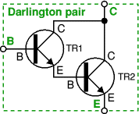
.

This is two transistors connected together so that the current amplified by the first is
amplified further by the second transistor. The overall current gain is equal to the two
individual gains multiplied together:
Darlington pair current gain, h_{FE} = h_{FE1} × h_{FE2}
(h_{FE1} and h_{FE2} are the gains of the individual transistors)
This gives the Darlington pair a very high current gain, such as 10000, so that only a
tiny base current is required to make the pair switch on. A darlington pair behaves like a
single transistor with high current gain.

It has three leads which are equivalent to the leads of a standard individual transistor.
To turn on there must be 0.7V across both the base-emitter junctions which are connected in series inside the Darlington pair; therefore it requires 1.4V to turn on.
Darlington pairs are available as complete packages but you can make up your own
from two transistors; TR1 can be a low power type, but normally TR2 will need to be high power. The maximum collector current Ic(max) for the pair is the same as Ic(max) for TR2.
The Darlington circuit consists of two cascaded emitter followers with
infinite emitter resistance in the first stage. here the two transistor form a composite pair, input impedance of the second transistor consisting of the emitter load resistance of the first transistor.
• Darlington emitter follower has high input impedance than the single stage emitter
follower.
• Its voltage gain is less close to unity than a single stage emitter follower.
• The output impedance of a darlington circuit may be greater than or less than that of a
single transistor emitter follower, depending upon the value of resistance.
• Major drawback of Darlington transistor pair is that the leakage current of the first
transistor is amplified by the second; hence the overall leakage current is high.

A Darlington pair is sufficiently sensitive to respond to the small current passed by
your skin and it can be used to make a touch-switch as shown in the diagram. For this circuit which just lights an LED the two transistors can be any general purpose low power transistors. The 100k resistor protects the transistors if the contacts are linked with a piece of wire.

6.0) Summary
Darlington pair is two transistors connected together so that the amplified current from the first is amplified further by the second transistor

7.0) Exercise questions
1. What are the advantages of Darlington pair?

Lecture # 6

1) Synopsis: Emitter follower
2) Target: At the completion of this lecture you should be able to answer questions like (a) circuit of an emitter follower (b)
3) Introduction
Common collector transistor amplifier is known as emitter follower. It is called so because voltage gain is close to unity and hence a change in base voltage appears as an equal change across the load at the emitter. In other words, the emitter follows the input signal.
. In particular, we will emphasize the following
(a)Emitter follower
(b)Characteristics
4) Revision / Prerequisites
Basic transistor configurations.
5.1) Concept #1
An emitter follower circuit shown in the figure is widely used in AC amplification circuits. The input and output of the emitter follower is the base and the emitter, respectively, therefore this circuit is also called common-collector circuit.
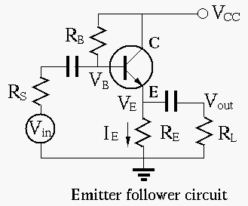
Npn Darlington Configuration
This emitter follower has a pair of transistors in the Darlington configuration. In this arrangement, the emitter current of one transistor becomes the base current of the second. The Darlington configuration acts like one transistor with a beta which is the product of the betas of the two transistors. They are used where high output currents are needed. The input impedance of the Darlington configuration is quite high.

Switching of the second transistor may be slow, so a resistor is commonly tied between the emitters to increase the speed switching. Darlington pairs are available as single packages, usually with the resistor included.
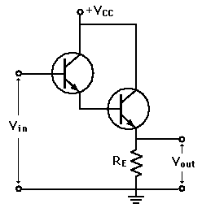
The emitter follower has the following principal applications:
1. To provide current amplification with no voltage gain
2. Impedance matching
Current amplification without voltage gain: Emitter follower is a current amplifier that has no voltage gain. There are many instances where an increase in current is required but no increase in voltage is needed. In such a situation, an emitter follower can be used. Consider the two stage amplifier. Suppose this two stage amplifier has the desired voltage gain but current gain of this multistage amplifier is insufficient. In that case, we can use an emitter follower to increase the current gain without increasing the voltage gain.
Impedance matching: An emitter follower has high input impedance and low output
impedance. This makes the emitter follower an ideal circuit for impedance matching.
The net result of this arrangement is that the maximum power is transferred from the original source to the original load. When an emitter follower is used for this purpose it is called a buffer amplifier. it may also be noted that the job of impedance matching can also be accomplished by a transformer. However the emitter follower is preferred for this purpose. it is because emitter follower is not only more convenient than a transformer but it also has much better frequency response ie.,it works well over a large frequency range.

.

6.0) Summary
Common collector transistor amplifier is known as emitter follower. The input and output of the emitter follower is the base and the emitter, respectively.

7.0) Exercise questions
1. Draw and explain the circuit diagram of a Darlington pair emitter follower.

